**CORE UA-400** Fall 2021 **| Texts & Ideas | Literature and Automatic Invention |**

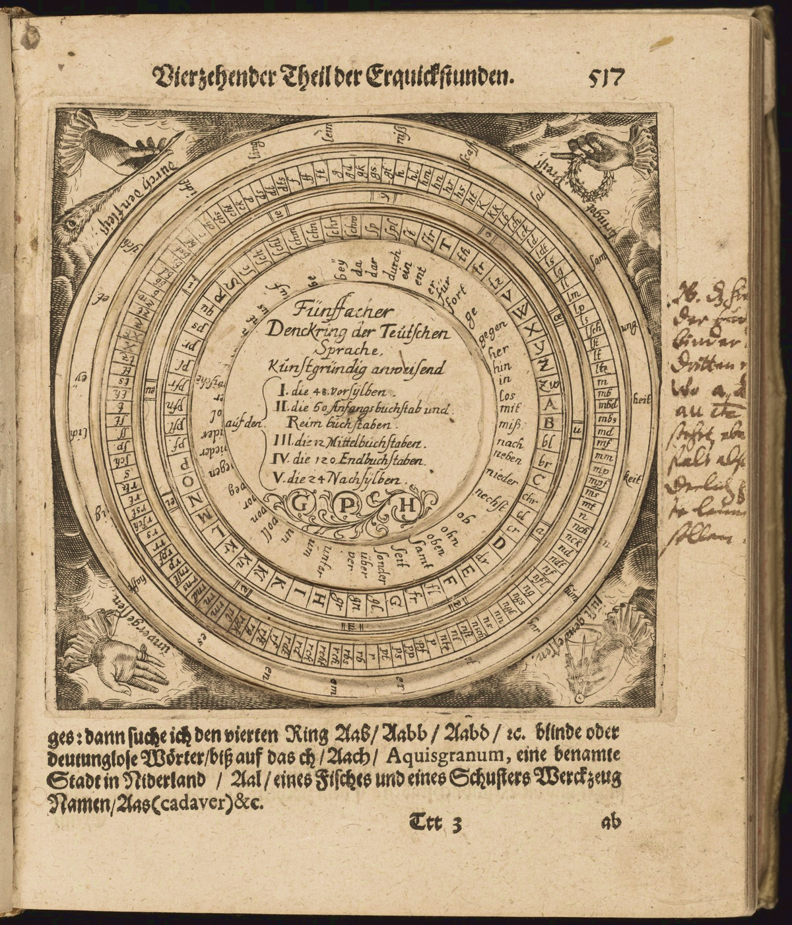

**Course Description**

Italian poet and futurist Filippo Tommaso Marinetti once described the ideal creative process as the unforeseen result of a “seemingly severed hand that writes.” The idea of using automatic procedures for literary purposes is not unique to Marinetti’s era. This course aims at outlining a tradition of text-generating methods across genres and time. We will encounter two broad groups of ‘text machines’. The first works on the assumption that certain mental states lead to a hidden repository of higher content. Psychic automatisms, dreams, trance-like states, inner dictation, and glossolalic runs are all means to explore an unconscious ‘other side’ — and often, a hypothetical superior realm mirrored in the hidden self. This ‘inherited automaton’ relies on the mind’s own automatic action. The second type foregrounds a procedural framework of made-up rules and constraints — the construction of a formal apparatus, sometimes very elaborate, of admissible elements and combinations. By running the wheels of such prosthetic automaton, the author seeks to obtain surprising stylistic and narrative results, all the while putting the text incommunication with its countless dynamic possibilities. Along with the various contributions to each of these ideal directions — the inner and the outer automaton — the course explores attempts to articulate connections between them. Readings include:E.T.A. Hoffmann’s *The Sandman*, William James *The Hidden Self,* Gertrude Stein’s *Tender Buttons*, Freud’s *The Creative Writer and Daydreaming*, Henry James’s *The Jolly Corner*, Marinetti’s *Futurist Manifesto*, Kafka’s *In the Penal Colony*, Breton’s *Soluble Fish*, J.L. Borges’ *Library of Babel*, Stanislaw Lem’s *The First Sally*,John Cage’s *Composition as Process,* ItaloCalvino’s *Castle of Crossed Destinies*.

**Learning Objectives**

In this course students will:

* become acquainted with classical methods of invention and with their modern reception.
* become acquainted with philosophical questions related to imagination and to meaning-making processes.
* reflect on the role of the authorial figure and of the authorial voice with respect to literary traditions that de-emphasize or complicate the notion of intent
* discuss the development of machine aesthetics during the XIXth-XXth century.
* familiarize themselves with the evolving concept of “machine” in its distinct usages from the pre- to the postmodern era.
* analyze literary artifacts driven by self-imposed recursion, automatisms, and chance operations.
* develop strategies for close reading through practice on a variety of textual sources (short novels, poetry, artistic manifestos, psychological studies, philosophical essays).
* become aware of the role of artifice and formalism in literary creations.
* reflect creatively on constraint and indeterminacy as accessible tools for textual production.

***Text and Ideas*** *classes introduce students to the ideals of liberal education and the central role of humanistic study in the liberal arts and foster appreciation of the importance of humanistic learning for society at large. Students become acquainted with some of the literary and philosophical works that have been most influential in shaping the contemporary world and with significant instances in which the ideas in these works have been debated, developed, appropriated, or rejected.* ***Texts and Ideas*** *is not a survey but, rather, an examination of how texts influence subsequent thinking, create traditions, and reflect societal ideals.* ***Texts and Ideas*** *thus aims to provide a richer understanding of how cultures are constructed, modified, and represented.*

**Instructors’ Contact Details**

Professor: Nicola Cipani | [nc39@nyu.edu](mailto:nc39@nyu.edu) | Casa Italiana, Office 408

Office Hours: after class or by appointment

Recitation Instructors: Matteo Ciambella | [mc4445@nyu.edu](mailto:mc4445@nyu.edu)

Katherine Travers | [klt330@nyu.edu](mailto:klt330@nyu.edu)

**Requirements**

Attendance and participation are required at all lectures and all recitation meetings. Students are expected to do the weekly readings ahead of each class, be prepared to contribute to discussions during the lectures and participate actively during the recitations. Students must notify the instructor(s) by email if they will not be able to attend a class because of illnesses/emergencies or religious holidays. A total of three unjustified absences from lectures and/or recitations will result in failing grade.

Assignments for a given recitation must be submitted before the beginning of the session. If students are unable to submit their assignment of time, they must contact the relevant instructor.

No late work will be accepted without prior clearance.

Students should contact the instructors if they feel that factors internal or external to the course are affecting or compromising their academic work. Issued should be addressed as soon as they come up, without waiting for when they are too late to be solved.

**Assessment**

**15%** Attendance (lectures and sections) and Class Participation

**20%** Recitation Exercises (papers, 1-2 pages long, assigned on weekly readings at intervals through the course). Students will also be asked to initiate the discussion of the readings once in the semester through a five-minute oral presentation.

**15%** Mid-Term Exam (take-home exam: students will be asked to answer an essay question based on the close-reading, analysis and discussion of a set of materials provided by the instructor).

**20%** Final Paper (6-8 pages, comparative analysis of any two of the sources studied in the course). Draft required two weeks before the final assessment submission date. All students must meet individually with their recitation instructor for feedback and comment.

**15%** Creative Project (written/audio/visual assignment; 4-5 pages / 3-5 minutes, or other format to be discussed and approved by the instructor). Students are expected to use this opportunity to reflect creatively on any aspect of the course. The instructors will provide a list of activities that students may use as prompts for the projects (e.g. visits to museums and galleries, performing arts events, etc.). Students are encouraged to make the most of the opportunities available in their respective locations.

**15%** Final Exam (same format as the midterm).

**Exam Dates**

Midterm: TBA  
Final: TBA

Specific time-windows and relevant submission deadlines will be confirmed.

**Written Assignments Deadlines (not including recitation papers)**

Creative project: TBA

Final paper draft: TBA

Final paper: TBA

**Course Materials**

Readings will be available on the course website or as electronic editions through the NYU library catalogue. Readings are assigned on a weekly basis, unless otherwise notified.

Weekly Schedule

|  |  |
| --- | --- |
| **Introduction** | |
|  | |
| Hildegard von bingen - litterae ignotae.jpg | *A Free Flow of Words* |

|  |  |
| --- | --- |
| **Day 1** | Raymond Queneau, *Hundred Thousand Billion Poems* |
|  |  |
| **Day 2** | Jorge Luis Borges, *The Library of Babel* |
|  |  |

|  |  |
| --- | --- |
| **Part 1 | Methods of Invention** | |
|  | |
| Man Ray's Black and White To Be Sold at Christie's France | *Dream Inspiration* |

|  |  |
| --- | --- |
| **Day 3** | Synesius, *On Dreams* |
|  |  |

|  |  |
| --- | --- |
|  | *Poetry Machines from the Baroque* |

|  |  |
| --- | --- |
| **Day 4** | Selection of poems by E. Puteanus, J. Caramuel, B. Bauhuis, G. P. Harsdörffer, I. Paschasius |
|  |  |

|  |  |
| --- | --- |
| **Part 2 | Automatic Narratives** | |
|  | |
| An engraving from the April 2, 1887, edition of "Frank Leslie's Illustrated Newspaper" shows a séance with a floating guitar and a spirit hand writing messages. (Courtesy of MysteriousPlanchette.com) | *Uncanny Duplicities* |

|  |  |
| --- | --- |
| **Day 5** | E. T. A. Hoffmann, *The Sandman* |
|  |  |
| **Day 6** | William James, *The Hidden Self* |
| **Day 7** | Henry James, *The Jolly Corner* |
|  |  |

|  |  |
| --- | --- |
| In the Penal Colony by Franz Kafka | *Writing Machines* |

|  |  |
| --- | --- |
| **Day 8** | Franz Kafka, *In the Penal Colony* |
|  |  |
| **Day 9** | Stanislaw Lem *The First Sally, or Trurl’s Electronic Bard* |
|  |  |
| **Day 10** | Primo Levi, *The Versificator* |

|  |  |
| --- | --- |
| **Part 3| Twentieth Century Experimentalism** | |
|  | |
|  | *The automatic message and the Avant-Garde* |

|  |  |
| --- | --- |
| **Day 11** | F. T. Marinetti, *Selections from Futurist manifestos and poems* |
|  |  |
| **Day 12** | Tristan Tzara, Pablo Picasso, *The Rose and the Dog*  *Selections from Dada manifestos* |
|  |  |
| **Day 13** | Louis Aragon, *A Wave of Dreams*  Sigmund Freud, *Creative Writers and Day-Dreaming* |
|  |  |
| **Day 14** | André Breton, *Manifesto of Surrealism* |
|  |  |
| **Day 15** | André Breton, *Soluble Fish* |
|  |  |
| **Day 16** | Gertrude Stein, *We came*  Gertrude Stein, *Cultivated Motor Automatism* |
|  |  |
| **Day 17** | Gertrude Stein, *Tender Buttons* |
|  |  |

|  |  |
| --- | --- |
|  | *Literature as Radical Artifice* |

|  |  |
| --- | --- |
| **Day 18** | Raymond Roussel, *How I Wrote Certain of My Books* |
|  |  |
| **Day 19** | Raymond Roussel, *The Alley of Fireflies* |
|  |  |
| **Day 20** | Oulipo Manifestos |
|  |  |
| **Day 21** | Jacques Roubaud, *E*  Raymond Queneau,*Yours for the Telling* |
|  |  |
| **Day 22** | Raymond Queneau,*Exercises in Style* |
|  |  |
| **Day 23** | Italo Calvino, *The Castle of Crossed Destinies* |
|  |  |
| **Day 24** | Italo Calvino, *The Castle of Crossed Destinies* |
|  |  |
| **Day 25** | Nanni Balestrini, *Tristano* |
|  |  |

|  |  |
| --- | --- |
|  | *Indeterminacy* |

|  |  |
| --- | --- |
| **Day 26** | Dieter Roth, *246 little clouds* |
|  |  |
| **Day 27** | La Monte Young, *An Anthology of Chance Operations* |
|  |  |
| **Day 28** | John Cage, *Composition as Process* |
|  |  |